Login to Admin Area - <http://elecbits.in/admin_area/>

Username – [kp@gmail.com](mailto:kp@gmail.com)  
Password – 567

Go to **Insert Lesson**  
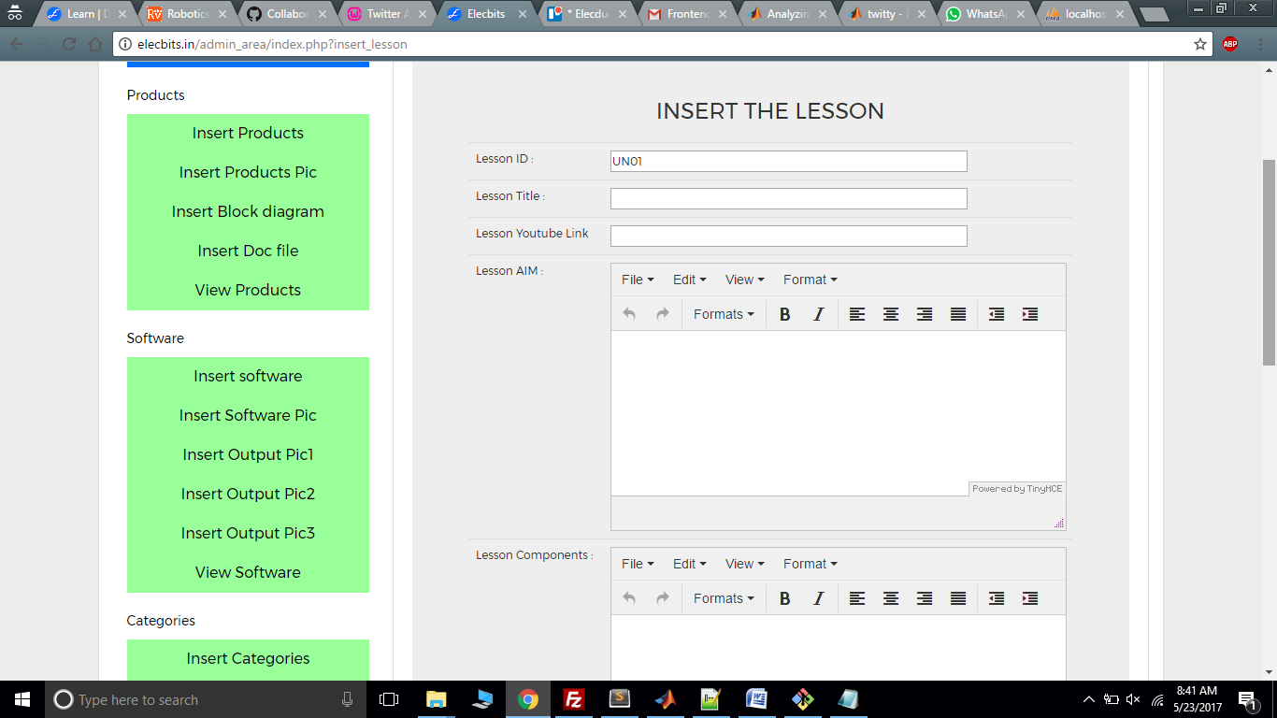 **Add the data in the fields from the**  
  
Use Lesson ID as “UN01” and increase sequence to 02, 03 as it proceeds.  
Use YouTube link from the view lessons and paste the same for every lesson.   
Use the **view lessons** for editing the lesson you have added.   
  
Once you’ll add the lesson. It can be visible on the front end that is   
<http://elecbits.in/elearn/myaccount/> -  
  
Login Using – username – [abc@gmail.com](mailto:abc@gmail.com), password – 787  
  
  
We have 15 projects and we have to understand the data from the above file which I have added  
and add the data to the backend. It needs to be **USER UNDERSTANABLE.**